Shabbos Stories for
Parshas mattos-masei 5780
Volume 11, Issue 45 26 Tammuz / July 18, 2020
Printed L’illuy nishmas Nechama bas R’ Noach, a”h

For a free subscription, please forward your request to keren18@juno.com
Past stories can be found on the website ShabbosStories.com

The Klausenberger Rebbe And Dovid Ben-Gurion
By Rabbi Tuvia Bolton

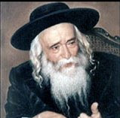
The Klausenberger Rebbe, zt”l

The first story is about the Rebbe of Kloisenberg; Rabbi Yekusiel Yehuda Halberstam during the holocaust.
Rabbi Halberstam lost his parents, his wife, all his eleven children and over 250 members of his immediate family to the Nazis but miraculously survived. He remained a beacon of light and optimism for all those around him throughout the ocean of torture, disease and death and after the war he remarried and built a family as well as many institutions of Torah and kindness.
Years later in Israel he spoke at the grand opening of the Kloisenburg Synagogue in Tel Aviv and told the following story
"We were two of about 3,000 Jews that the Germans took from the death camp Birkenau 1944 to clean the ruins of the Warsaw Ghetto. The work was backbreaking, almost non-stop, escape was out of the question and we were guarded closely so we couldn't even rest.
"Then, early one blisteringly hot summer morning, the Germans told us to line up in rows of three and begin marching as fast as possible. The Russians were closing in on Warsaw and they didn't want to leave behind any evidence.
"The heat was unbearable; we could barely stand no less walk but it made no difference to the Germans. Making progress and marching in line were their only interests. They had enough bullets to kill everyone. Dogs and Nazis were barking everywhere.
"Anyone that stepped out of line, even one step, was immediately shot. It was especially awful when we passed a river or a brook. The thirst was so intense that the sight of water simply drove some people crazy and, unable to hold themselves back, made a move toward the water and were instantly riddled with bullets before everyone.
"It was clear that the Nazis wanted us to die one at a time and fall by the wayside. But I told all those around me to pass the word not to let the Nazis win. No one was to step out of line for any reason and I promised that there would be water.
"I answered, 'Each of you has a spoon, right? (the Germans gave each Jew a crude spoon to eat the 'soup' when apportioned). 'Pass the word that each person should take their spoon and dig in the ground where they are and they will find water."
"The road was totally dry surrounded by open fields and there was no trace of water as far as the eye could see. It was totally impossible that there would be water in this wasteland.
"But with nothing to lose, everyone took out their spoons and lifelessly scraped the dirt where they were laying, and lo and behold, a miracle!! Each one found water! Everyone’s spoons filled with water over and over again. They were saved!
He then pointed to someone in the [Tel Aviv] crowd and said 'Aba Halperin! Tell them' and then announced to the crowd, "And if you don't believe me you can ask Rabbi Aba - he was there." (Shaa Tova weekly magazine #309).

The second story is from Rabbi Menachem Porush, ob'm, who was the leader of the Religious Agudat Yisroel party in the Knesset. He had many meetings with the Lubavitcher Rebbe and once he told the Rebbe the following story about Dovid Ben Gurion the first Prime Minister of Israel.
Often, I had opportunities to discuss various topics with Ben Gurion. He was a fascinating person to speak to. His perspective of historical events was unique. He really loved the Jewish people and believed he was doing the best for them. And although he was not at all an observant Jew and in many ways opposed them, he enjoyed speaking with me. During one of those conversations, I asked him what was the most difficult moment for him in his entire career?
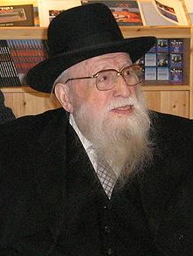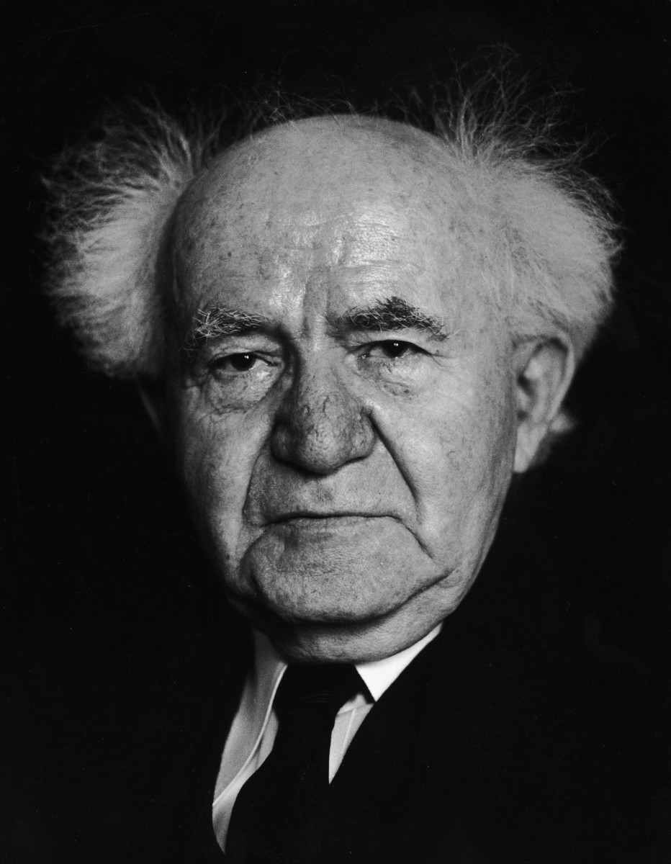

Rabbi Menachem Porush and David Ben-Gurion
He immediately replied with this surprising story. He said that when the establishment of the state of Israel was announced, the British pulled out, the Arabs attacked from every side and murderous battles waged on several fronts. All the Arab nations were against us and we were alone. No one helped us and we were very short on weapons. We were lacking not only artillery but even rifles.
After superhuman efforts we were able to obtain a miniscule cache from Russia and some other countries promised. But what we actually received wasn't enough to cover all the fronts. So I was faced with a very serious dilemma; who would receive the guns?
Each commander, many of them close friends of mine, presented himself before me begging for weapons. Each had his own reason why it was imperative that the guns be given to them. Those in the north, in the Galilee, locked in battle with Syria over strategic positions, came to me and cried, 'While you sit here in safety, we are outnumbered and under armed, our best young men are falling, lacking the most basic weapons. Give us guns, so we can protect this land, or all will be lost.'
From Central Command in Tel Aviv, where hostile forces were being held back from completely overrunning the heart of the country, came the besieged Hagana leaders, who demanded, 'We must have more equipment; the majority of our civilian population are under incessant fire, and without stocking our depleted stockpiles, we will be compelled to surrender.'
"Harassed and fatigued, the generals from the Negev arrived next, pleading for every morsel of weaponry they could receive, 'If you don't supply us with adequate arms, we will be powerless against the armies of Egypt invading the South, putting at risk all of the inhabitants of the land.'
"Last of all came the contingency defending Jerusalem. Heads drooping on their tattered uniforms and shoulders slouching under the heavy weight of battle, they lifted their weary eyes and simply said, Although there may not be many Jews in the city, it is crucial to the future of the nation that Jerusalem remain in our hands; Jerusalem is the spirit and heart of our people, Israel without Jerusalem Israel would be like a body without a heart and a head.'
"I was faced with a moral quandary, and this was the toughest decision in my life; how can one make such a choice? Who is to decide which region is more vital and which people best deserve to live? My anguish was inconceivable, but I had to make a judgment. In the end, I allowed my emotional instincts to override strategic concerns; the argument about Jerusalem's centrality in Jewish religion and history prevailed, and I handed over the weapons to those guarding the city.

The Lubavitcher Rebbe, zt”l

Rabbi Porush continued "The Rebbe, had been listening attentively to every detail and I observed how deeply moved, and surprised he seemed by the end. Apparently, finding it hard to believe Ben Gurion had behaved that way he asked me to repeat exactly what he said.
When I did so the Rebbe said:
“This is a tremendous achievement, an incredible merit. I marvel how Ben Gurion acquired the great merit to make such a monumental and correct decision."(Ascent of Safed, Story #709)

Reprinted from the Parshat Chukat-Balak 5780 email of Yeshiva Ohr Tmimim. In Kfar Chabad, Israel.

The Chofetz Chaim’s
Fear of Chillul Hashem
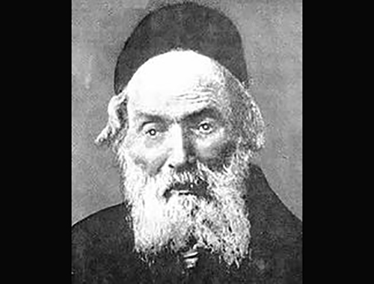

In his older age, the Chofetz Chaim, OB”M, was extremely weak and fragile, could not even look into a Sefer (Torah book). He nevertheless asked for a Sefer to be brought in front of him and opened, so that no one would think that he was sitting idly wasting his time.
In a similar vein, once the Chofetz Chaim came somewhat late to davening. After the prayers, he walked up to the Bimah and announced that the reason for his delay was not because he overslept. Rather, he woke up early and immersed in a complex Torah subject, and was unable to detach himself from it until it was totally resolved. To confirm this, he shared with the participants the freshly developed insight that he managed to bring to light. (Story from “Daily Dose of Torah”)
Comment: Many people have big misunderstandings about Chillul Hashem – Desecrating the Name of Hashem (see Sugar Rush Insights). One of the misconceptions we may have is that Chillul Hashem is reserved only for big transgressions and only to certain people.
The Talmud (Yoma 86a) tells us that there are different levels of Chillul Hashem (defamation of Hashem’s Name); the higher a person’s level of spirituality, the more careful he must be not to defile Hashem’s Name, and the easier it is for him to cause a Chillul Hashem.
For the average gentile, a Jew who looks Jewish – or even more superficially, dresses in “Orthodox garb” is automatically judged on higher standard. Any sort of deviant behavior, like lack of social distancing or not wearing masks in public, is not met with patience but with outrage. True, there is often a double standard. Yes, we should have our Jewish activists fight for our rights and speak out against us being singled out. Yet, at the end of the day we have to realize that for the masses, optics carry the most weight.

Reprinted from the Parshas Emor 5780 email of Torah Sweets Weekly (edited by R’ Mendel Berlin).
L’Maaseh
The Unusual Fascination
Of the Lecha Dodi Zemira

In the city of Bnei Brak lived a man who took upon himself to invite guests to his house every Shabbos. This man was very meticulous in regard to this so that no Shabbos should pass without a guest.
One Friday as he was finishing his preparations for Shabbos and darkness was beginning to descend, he became aware that despite all his efforts he was not successful in bringing a single guest home for Shabbos. The man decided that after Maariv he would walk to the nearby city of Ramat Gan to try his luck, and perhaps he would find someone who was still looking for a place to eat on Shabbos.
After some time, he found a young man and he asked him to join him for the Seudas Shabbos. The young man accepted the invitation and together they walked to the house of the host.

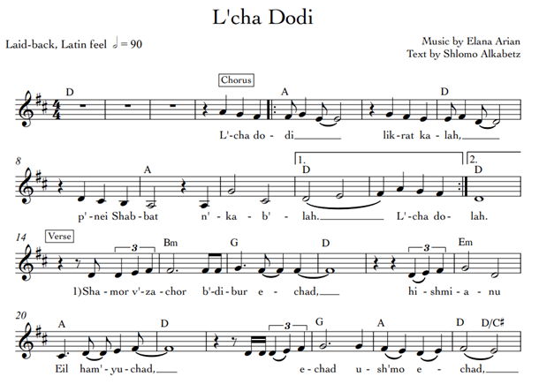

During the course of the meal, the host began to sing Shabbos Zemiros, and at the end, he sang ‘Lecha Dodi’. The young man was deeply moved by the unique melody of the song, and he asked the host to sing it a second time, and then again for a third time.
After the meal, the young man was about to leave, and the host invited the boy to come back for the Seudah the next day. The young man agreed, but on the condition that the host would again sing ‘Lecha Dodi’ for him the next day as well. Of course the host agreed, and the next day the young man showed up, and as promised, they both sang ‘Lecha Dodi’ together.
The young man stayed for the rest of Shabbos. After Shabbos, before they parted, the young man informed his host that he was not at all Jewish, but because of the special unique melody that made an impression on him, he now wished to convert.
The host tried to dissuade him from this, but the young man was determined to convert, and he just had to inform his mother about this. The young man travelled to the town where his parents lived, and he let his mother know of his intent to convert, and the reason for this was the special melody that he heard, and he began to sing her the song of ‘Lecha Dodi’.
The mother, upon hearing the tune, became emotional, and she told her son that she had to tell him a lifelong secret. “I am Jewish,” began the mother, “and I married your father, a gentile [Arab], and because this is so, you do not have to convert, since you were born to a Jewish mother.”
When she finished, the mother went and brought a special picture that she had inherited from her Jewish family, and by word of mouth, this was the forefather of the family from several generations ago. The boy took the picture and began reading the inscription at the bottom: Rabbeinu HaGadol (our great Rabbi), Rebbe Shlomo Alkebetz, composer of the Piyut “Lecha Dodi”! (He’emanti V’adabeirah).

Reprinted from the Parshas Emor 5780 email of Torah U’Tefila as compiled by Rabbi Yehuda Winzelberg.
A Word for the Ages
The Gift of Forgiveness

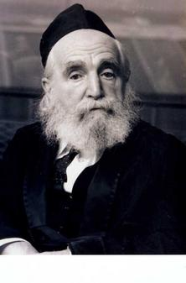
Rav Moshe Feinstein, zt"l, was affectionately known to all to be a model of having kindness, compassion, and concern for others. Once, someone whom Rav Moshe had never met, sent him a letter of apology for having spoken disrespectfully concerning one of the Rav's Rabbinic rulings.
The man wrote that he was so troubled by what he had said that he had difficulty sleeping at night, and he begged Rav Moshe for forgiveness. Of course, Rav Moshe (who once said that he had never held a grudge against anyone) forgave the man.
But to Rav Moshe, that was not sufficient enough. It was imperative that he put the man's mind at ease as quickly as possible. Using the envelope's return address, Rav Moshe obtained the man's phone number and called to tell him that he had forgiven him. Rav Moshe Feinstein clearly went above and beyond when it came to the care and sensitivity of others!

Reprinted from the Parshas Emor 5780 email of Torah U’Tefila as compiled by Rabbi Yehuda Winzelberg.

Rav Lopian and a
Mice-Catching Cat
By Rabbi Moshe Brandeis

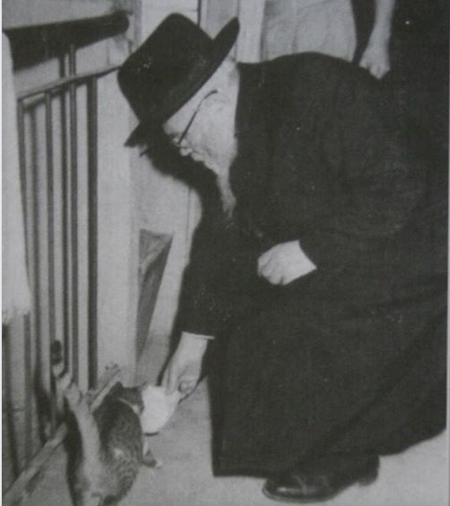

But perhaps my favourite illustration of this principle is the story of Rav Elya Lopian and a certain hungry cat: Rav Elya served as the Mashgiach of Yeshivas Kfar Chasidim.
The dining room of that yeshiva was situated in a makeshift hut, where there was once an infestation of mice. The bochurim brought in a stray cat to deal with the pesky rodents and after a few weeks the only squeaking to be heard was from the hut door’s rusty hinges.
It happened then that Rav Elya came into the dining room to investigate a commotion he had overheard. One of the students told him that since the rodents had gone, the cat’s position was now redundant, and they were removing her from the premises.
“What will be with hakaras hatov?” exclaimed Rav Elya, and insisted that the cat should remain at the yeshiva. The boys, of course, were unsure how to look after a cat they had never had to feed, so Rav Elya demonstrated how to do so.
And as Rav Elya put a saucer of milk down before the cat, a young talmid named Kavinsky captured the moment on camera. The picture of the sage bending down and feeding a cat remains one of the most iconic images of the Torah World until this very day

Reprinted in the Parshat Chukas-Balak 5780 email of Oneg Shabbos (London, UK)

Never Give Up on a Soul’
By Rabbi Dovid Goldwasser

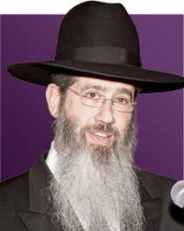
Rabbi Dovid Goldwasser

Years ago, a Jew by the name of Rav Tzadok lived in Europe and made a living as a wagon driver. Known to be a supremely pious Jew, he would mouth words of prayer and Tehillim all day long. Despite his long days of work and driving near and far, he never wavered in his commitment to Yiddishkeit.
Yet, as Rav Tzadok grew older, he began to feel a deep-seated sense of sorrow in his life over one particular aspect that he wished he could do more for: his son. His only son was irreligious and had done away completely with a life of Torah.
With Rav Tzadok’s own, personal dedication to Torah so important, he wondered what he could do to encourage his son to find such fulfillment in his life as well. But Rav Tzadok knew that it would not be simple to do so, as his son in no which way embraced his heritage and ancestry of illustrious Torah Jews.

As the Final Days of Life Neared,
He Penned A Will for His Son
But as Rav Tzadok’s final days of life neared, he penned a will, and included within it a special request that his son recite the traditional Kaddish prayer after his passing. Nothing more was asked of the son but to say Kaddish in merit of his father’s soul.
Truth be told, after Rav Tzadok passed on, his son began to ruminate over his father’s lifetime. While the son was certainly not following in his father’s ways, and that was not going to change, at the very least, he could pay honorary dues by fulfilling his departing wish. That was the one request he could actually commit to. After all, Rav Tzadok had been a loving and supportive father.
And so, the next day, off went the son to the local shul in earnest intent to recite Kaddish. But he didn’t get too far, as the shul members recognized him immediately and threw him out.
“What are you doing here?” they berated him. “You don’t belong here! You are going to defile us! You are going to make us impure!”

He Tries to Enter a Second Shul
Without any other choice, the son ashamedly walked out. But he wasn’t ready to give up so easily. Off he went to another shul. But the same scene repeated itself. “Get out of here! You’re not staying here!” they yelled.
But that’s not all. This shaming scene unfolded even a third time. But, despite not being interested in Judaism, the son was not a quitter. He wouldn’t let go of what he said he would do. If he had made a commitment, he would do absolutely everything possible to complete it.
He entered into yet another shul, that of Chassidic Breslov Jews. They welcomed him in, and accepted him non-judgmentally and respectfully. For the next six months, all he did was recite Kaddish. No Shema, no Shemonah Esrei, no Tefillin. Just Kaddish.
One day, a fellow by the name of Rav Yankel approached the son. With love and care, he asked if he would like to put on Tefillin. Rav Yankel’s gentle words, warmth and authenticity were evident, and the son complied. It wasn’t long before one mitzvah led to another. The son continued putting on Tefillin, reciting Shema and Shemonah Esrei and learning.
However, there came a time not too long thereafter, that the government issued a mandate, resulting in all the mikvaos in town forcibly being closed. The foundation of the Jewish home, that of taharas hamishpacha (Family Purity), was put into jeopardy.

A Most Unusual Request
With this occurring, Rav Levi Yitzchak Bender approached the son of Rav Tzadok. “You are a gifted man,” he told the son. “You have talented hands. We are in dire need of a mikvah to serve our community. If you could commit to building a secret mikvah that would not be known to anyone but those members of our community, it would be an unbelievable blessing, and Family Purity could continue in our region.”
The son of Rav Tzadok, with his artistic hands and masterful mind, built a mikvah and covered it over so well that a horse and wagon could drive over it, and no one would have known that a mikvah was underneath. To the son’s credit, the practice of taharas hamishpacha resumed in the region.
Even the day that the government caught wind that there was a mikvah in the Jewish community, and sent out officials to look throughout the city, they found nothing. Rav Tzadok’s son had done such a brilliant job camouflaging it that they walked right over it and never discovered anything.

The One Who Was Accused of Defiling the Shul
This son, the one who was told these very words, “You are going to defile us! You are going to make us impure!” was the very individual who brought purity and holiness to the entire community.
Each and every one of us possess the incredible potential and power to purify, uplift and inspire ourselves and those around. We are capable of igniting ourselves, and with that, diffusing light to others. That fire and passion can become so great that we spread it to others and touch their lives in the most profound of ways. Never, ever give up on a Jewish soul, because you never know where it may go.

Reprinted from the Parshas Chukas-Balak 5780 email of the Torahanytime.com Newsletter. Compiled and Edited by Elan Perchik

As Long As The
Candle Still Burns...

The pasuk in (Iyov 5:7) says– For man is born to weariness. Naturally, we love rest and relaxation. We look forward to taking it easy. Our real job here, however, is to work. Very often, when we are pressed, it brings out the best in us. Each day of life provides countless opportunities for growth. A person can still flourish even at an advanced old age.
Rav Yisrael Salanter passed the home of a cobbler late one night and he noticed through the window that the candle was still lit and the cobbler was diligently working. Intrigued that a shoemaker would still be toiling late at night, Rav Salanter knocked on the door and asked him why he was working at that late hour. “As long as the candle is still burning,” the cobbler replied, “there’s still time to make repairs.”
Hearing these words from the shoemaker filled the Rabbi with excitement. The human soul is compared to a candle, he thought. And as the shoemaker taught, as long as the light still burns, as long as a person still has life, he can still make repairs and improve himself.
There's a famous story that was told over by Rabbi Frand at the last Siyum Hashas at Met life stadium 7 years ago, about a man who never learned Torah. His son on the other hand became a baal teshubah and grew to become a Talmid Chacham.
After many years the father approached his son and asked him if he can learn with him because he said that he see's the enjoyment that his son gets from his learning Torah.
Of course the son agreed and they began learning one page of Gemarah. They reviewed that page many, many times without moving forward. The father owned that page of Gemarah because he really toiled in it until he knew it by heart. He was so elated by his accomplishment that he decided to made a siyum on that one page of Gemarah.
Rabbi Frand continued that unfortunately not long after that, the father had passed away suddenly. It was said over about the mitzvah that in Hashem's eyes completing that one page of gemarah for this man was considered in heaven as if he had mastered all of Shas!
A word about the Coronavirus…
Do We really appreciate the Air that’s free to us all our lives? After a 93 year old man in Italy got better in the hospital, he was told to pay for the ventilator for one day, and the old man cried. The doctor advised him not to cry over the bill. What the old man said made all the doctors cry.
“I don’t cry because of the money I have to pay. I can pay all the money. I cry because I have been breathing G-d’s air for 93 years but I never paid for it. It takes $500 Euro to use a ventilator in a hospital for one day. Do you know how much I owe G-d? I NEVER thanked G-d for that before!”
The truth of the news cannot be verified, but the old man’s words are worth our reflection. When we breathe the air feely without pain or illness, no one takes the air seriously. Only when we enter the hospital can we know, that even breathing oxygen with a ventilator costs money!
May we always continue to learn Torah and make it a priority of our days and nights. May we also have the greatest respect for our Rabbis who devote themselves to studying and teaching Torah selflessly to our community for our benefit. Amen!

Discussion Points:
How would you feel if Hashem commanded you not to work for a whole year every seven years? Today we’re getting a taste of it through this lockdown by having trouble not working for just a few months!
How good is our Shabbat observance and how can we make it better?

Reprinted from the Parashat Behar/Behukotai 5780 email of Rabbi Amram Sananes as written by Jack E. Rahmey.

